ECHOES

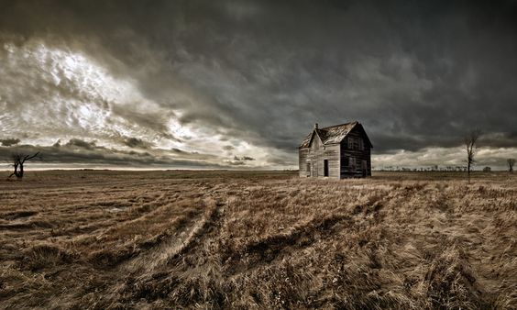

Writers

Phil Rowlands and Jordan Wheeler

how grief can destroy a dream and the human spirit overcome even the greatest tragedy.

**World**

**Manitoba, Canada 1909**

**The ever expanding Canadian Pacific Railroad inches its way across the great plains of central Canada, shambolic one street towns spring up in its wake, a melting pot of hopeful immigrants, Poles, English, Germans, Irish, Norwegians, Welsh…  all searching for their promised land.  The indigenous Ojibwe people look on helplessly from their reserves with a palpable sense of betrayal as their ancestral lands are partitioned and fenced by the newcomers. There is a keen sense of adventure but also a simmering tension inevitable in the wake of such sudden change.**

**Synopsis**

**Into this world, from Wales, come Rhys and Betsi Jenkins with their six month old daughter, Gwennie.  When they step off the train they are met by Betsi’s cousin, Rachel, and her husband Gwyn. They have been promised a new beginning, a parcel of land on the prairie. Betsi, a free spirited twenty year old, is excited by this new adventure while Rhys, a reserved and pragmatic man of 23, is unsure, awed by the flat expanse of the prairie and the big sky that surrounds him.**

**They join an established community of Welsh settlers with their own chapel and ordered lifestyle. Rhys finds this comforting but Betsi is disappointed that the influence of the chapel is as strong as it was in Wales. She feels constricted by its small mindedness and particularly the attitudes of the controlling Rev Price towards women and the local indigenous people. Betsi is, however, fascinated by their culture and is drawn to their way of life and love of the natural world. She befriends Mary, the strong willed daughter of the local Ojibwe chief. This not only antagonizes Price but also Orme, the manipulative town bigwig, Mary’s father, Kazaway, and her controlling matriarchal aunt, Ekwayzance,**

**Tragedy strikes when Gwennie dies and Betsi’s world unravels and she and Rhys drift apart. Betsi withdraws into herself, shutting Rhys out of her life, distancing herself from the Welsh community and also Mary. Only Rachel is allowed into her closed world.**

**Price exacerbates the split between Rhys and Betsi by blaming Gwennie’s death on her lack of faith. She stays with Rachel in town whilst Rhys continues to live at the farm in the diminishing hope that she will return.**

**One night as Rhys returns to the farm from town having failed to convince Betsi to come back with him, he disturbs two of the railway workers as they attempt to rape Mary. He is badly beaten but manages to help her get away from them.**

**This is the first in a series of tumultuous events that ultimately lead to new beginnings for both Betsi and Mary.**

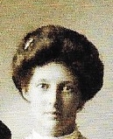

BETSI

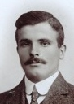

RHYS

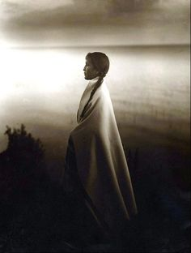*.*

MARY.

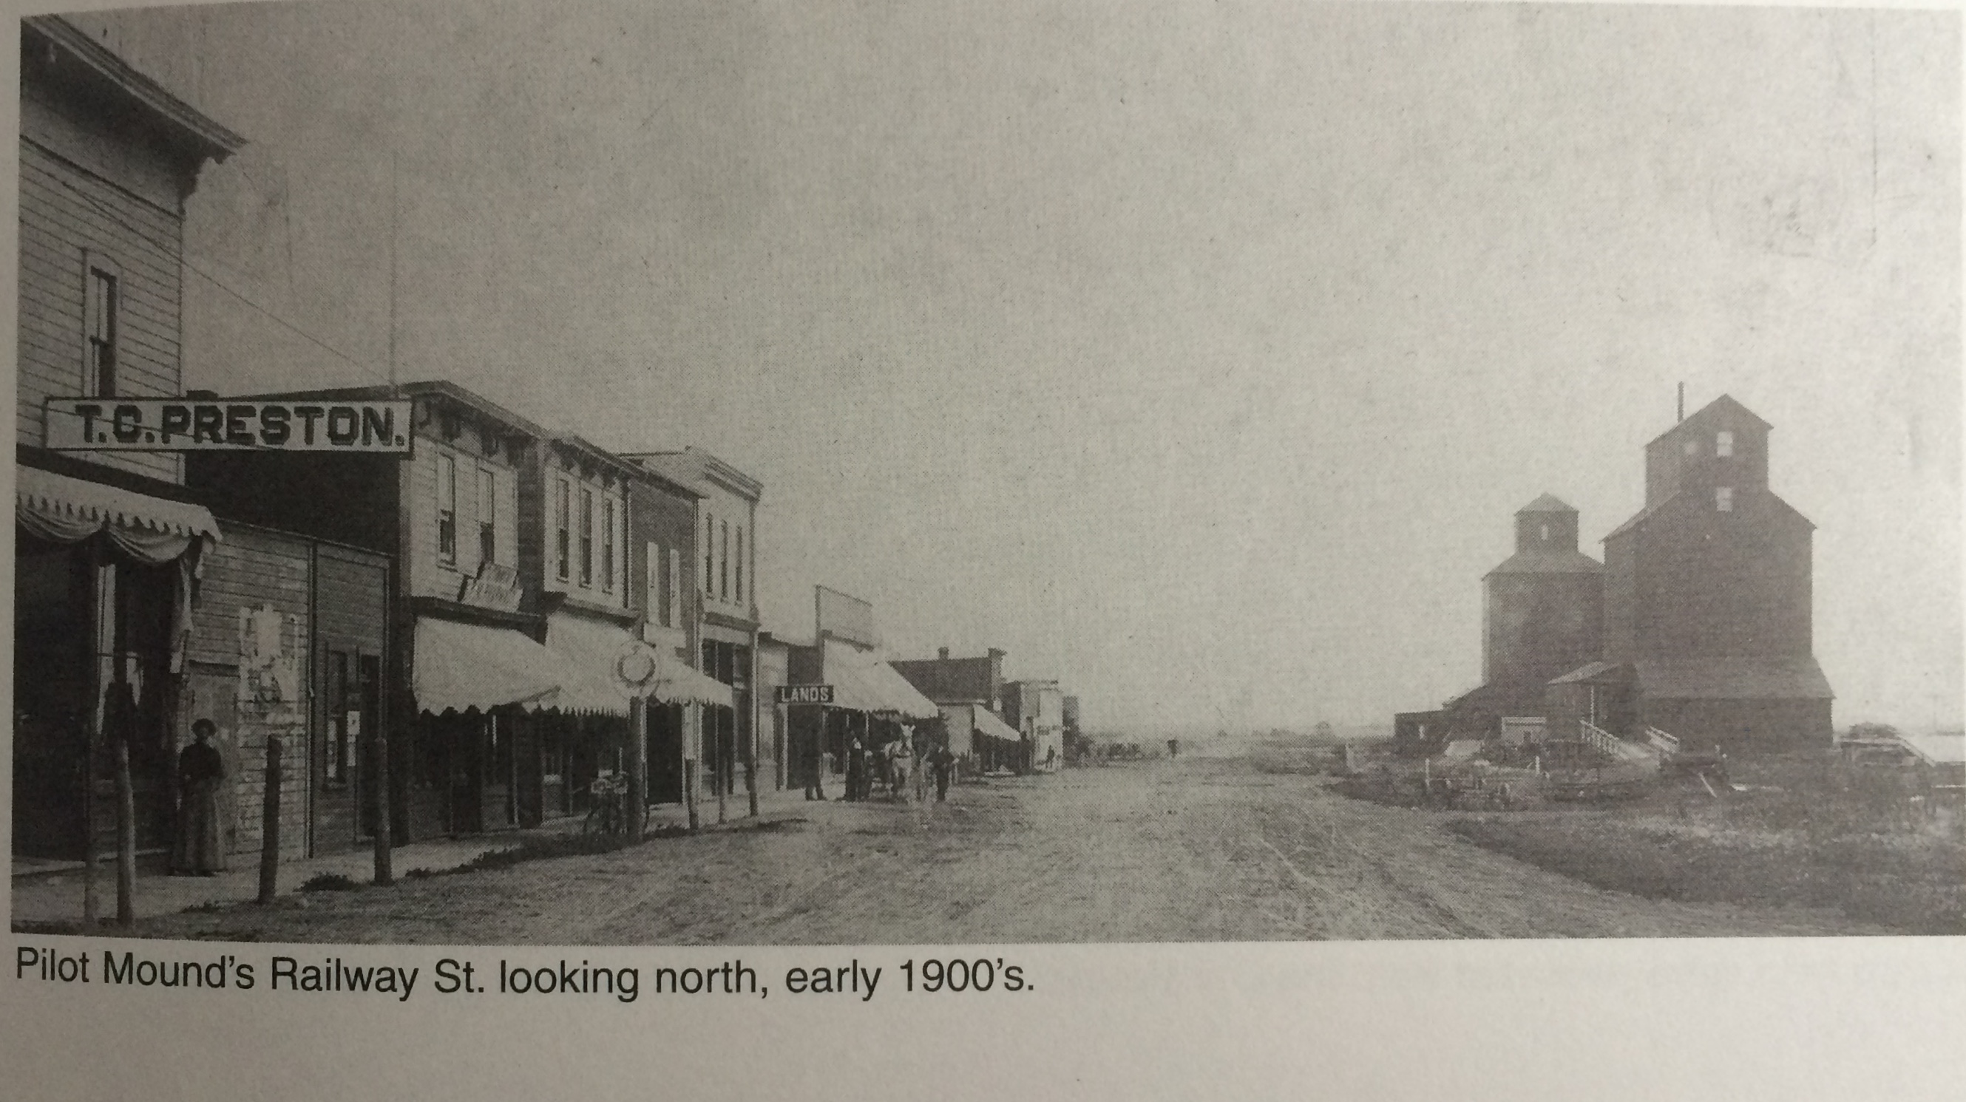

***Echoes is inspired by Phil Rowlands’ grandparents emigration in 1907 from a small rural community in West Wales to a 320 acre farm plot near Pilot Mound. Manitoba, Canada.***